**DAILY ONLINE ACTIVITIES SUMMARY**

|  |  |  |  |  |  |  |  |  |
| --- | --- | --- | --- | --- | --- | --- | --- | --- |
| **Date:** | **26/05/2020** | | | | | **Name:** | **SPOORTI S DAROJI** | |
| **Sem & Sec** | **4th SEM. & ‘B’ SEC.** | | | | | **USN:** | **4AL18CS088** | |
| **Online Test Summary** | | | | | | | | |
| **Subject** | | **DESIGN AND ANALYSIS OF ALGORITHM** | | | | | | |
| **Max. Marks** | | **30** | | **Score** | | | **23** | |
| **Certification Course Summary** | | | | | | | | |
| **Course** | **Python for Machine Learning** | | | | | | | |
| **Certificate Provider** | | | **Greatlearning**  **academy** | | **Duration** | | | **5 Hrs.** |
| **Coding Challenges** | | | | | | | | |
| **Problem Statement 1: Write a Program in C to print all permutations given string using pointers.**  **Enter the Input String: abcd**  **Expected Result:The permutations of the string are :**  **abcd abdc acbd acdb adcb adbc bacd badc bcad bcda bdca bdac cbad cbda cabd cadb cdab cdba dbca dbac dcba dcab dacb dabc**  **Problem Statement 2: Given an array A of size N where the array elements contain value from 1 to N with duplicates, the task is to find the total number of subarray which start & end with same element**  **Input: A=(1,2,1,5,2) Output:7** | | | | | | | | |
| **Status: Executed.** | | | | | | | | |
| **Uploaded the report in Github** | | | | | **Yes** | | | |
| **If yes Repository name** | | | | | [alvas-education-foundation](https://github.com/alvas-education-foundation)/[spoorti_daroji](https://github.com/alvas-education-foundation/spoorti_daroji) | | | |
| **Uploaded the report in slack** | | | | | **Yes** | | | |

**Online Test Summary: 18CS42 test was scheduled from 9:15AM to 9:55AM.The Portion for the IA was 2nd module there were 30 questions of one mark & the time assigned was 40 minutes. The questions were mcq type.**

**Online Certification course Summary: In today’s session I have learnt about the special function Reducer,Accumulator, Numpy Introduction.To use reducer function we should use functools library imported by f, operator library is imported by o.**

**To use an accumulator function we have to include the library itertools as i. Numpy is python’s package for doing math,even it includes special functions like cosine,exponential,sqrt,....As shown in the snapshot below.**

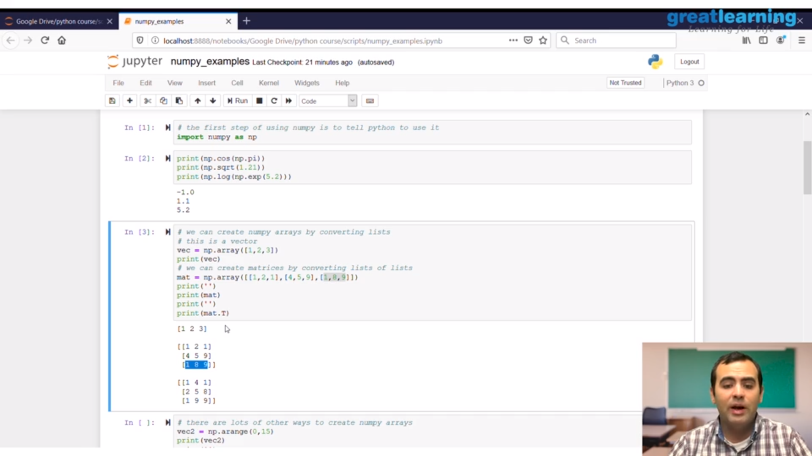

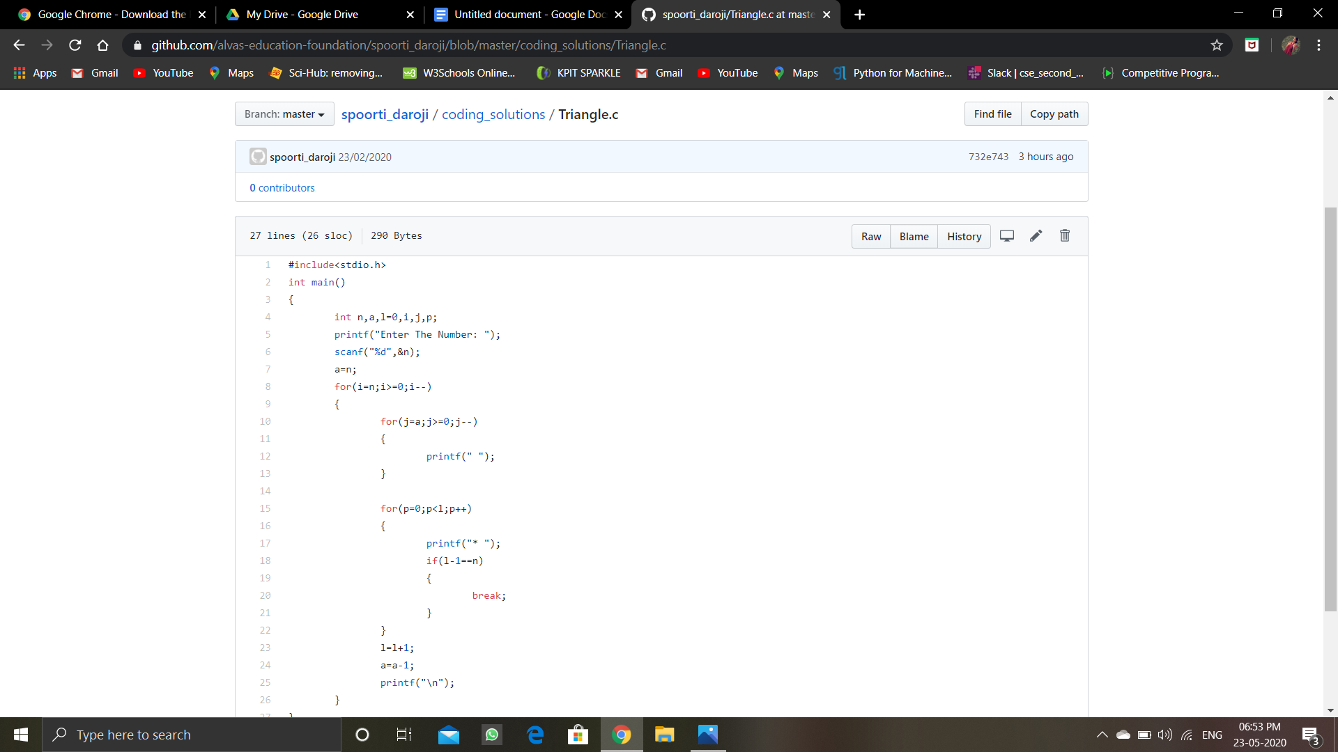

**Online Coding Summary: Today I received the program from prof.Venkatesh CSE Dept, and prof.Vasudev.S CSE Dept.**

**The program is mentioned above in the coding challenges.I have written a program and uploaded it to my Github repository, as shown in the below.**

